

Dear Volunteers:

Thank you so much for your offer to volunteer at our Walk at Knott’s Berry Farm. We know how valuable your time is and we appreciate that you have chosen to share it with us. Below is information about the day of the event. This is one of our largest fundraising events and it will only be successful because you are part of our team.

**DATE**: Sunday, March 12, 2017

**LOCATION**: Please check in at the pic-nic area on the East Side of Beach – *See map*

**ARRIVAL TIME**: 6:00 a.m.

**(NOTE: Day Light Savings Time starts on this day – please remember to adjust your clock.)**

**CONCLUSION:** 11:00 A.M. APPROXIMATELY

**DETAILS FOR ALL:**

1. **Attached is a Waiver** that should be filled out by all and brought with you to the Walk, you will not be able to volunteer without this document so please remember to bring it.
2. Parking can be accessed two ways. 1. Off of Grand Ave. going south off of Beach, @ the crosswalk you will go under the bridge. #2 Going north on Beach Blvd. enter into the parking for the Pic-Nic area,
3. Please proceed to the Volunteer Table and Check-in there.
4. You will then be directed to an area to assist with.
5. Be sure to wear comfortable shoes. Perhaps a jacket in the a.m. but something you can tie around your waist later in the morning as there will be no place to leave your jacket.
6. As a volunteer you may be asked to work various location. Some of the areas we will need help with are Set-up/Tear down of Kids Zone, Resource Fair and Walking Path, Registration, VIP Area and a multitude of other areas. Thank you for your flexibility.
7. When you check back at the Volunteer Table at the end of the Walk, we will give you a discount coupon as a “thank you” for your help. This coupon is good for up to 4 people. The value is $38 and it will expire in 30 days.

**SCHOOLS/CLUBS:**

1. Students - If you would like for us to sign off on your Community Service Hours – please bring your filled out form with you and we will sign it off at the end of the Walk at the same table you checked in at.
2. If you would like to wear your school or club shirts that is fine – however, we will have Volunteer Shirts.
3. If your group would like to make up a cheer, bring noise makers etc. Feel free, this will only enhance the experience. However, please do not bring anything of value and it must be something you can put away easily.

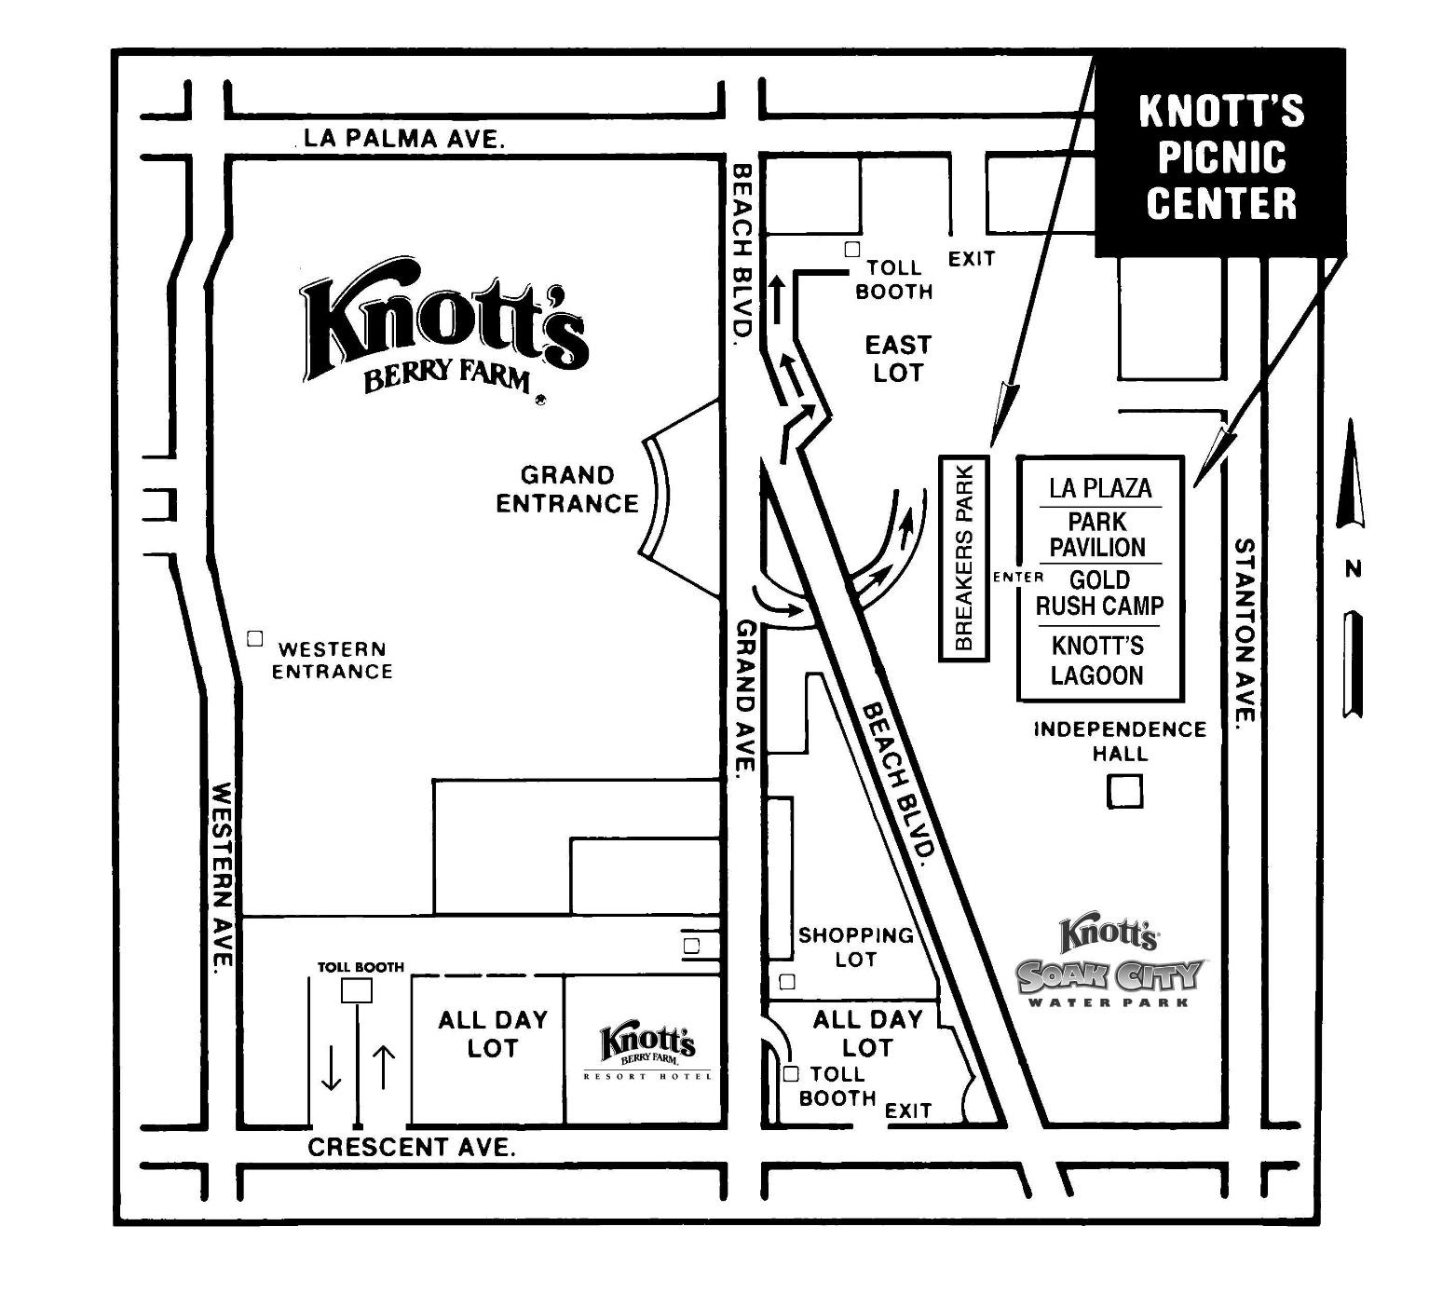

**VIP PARKING**

**PARK HERE**

**SLDC**

**WALK**

**EVENT**

**Knott’s Lagoon**

**PLEASE BRING SIGNED WAIVER WITH YOU ON SUNDAY**

**CHARITABLE EVENT AGREEMENT**

**EXHIBIT A**

**EVENT**: **2017 Walk on 03/12/17** (“Event”) **LOCATION**: **Knott’s Berry Farm in Buena Park, CA** (the “Park”)

**WARNING: READ CAREFULLY. THIS AGREEMENT INCLUDES A RELEASE OF LIABILITY AND WAIVER OF LEGAL RIGHTS AND DEPRIVES YOU OF THE RIGHT TO SUE SPONSOR AND OTHER PARTIES. DO NOT SIGN THIS AGREEMENT UNLESS YOU HAVE READ IT IN ITS ENTIRETY; SEEK THE ADVICE OF LEGAL COUNSEL IF YOU ARE UNSURE OF ITS EFFECT.**

**WAIVER AND RELEASE OF LIABILITY,**

**ASSUMPTION OF RISK AND INDEMNITY AGREEMENT**

**IN CONSIDERATION of Millennium Operations LLC d/b/a Knott’s Berry Farm, the parent company Cedar Fair, L.P. and their affiliates, and the sponsors allowing me to participate in the above referenced Event, I for myself, and on behalf of my spouse, children, parents, guardians, heirs and next of kin, and any legal and personal representatives, executors, administrators, successors and assigns, hereby agree to make the following contractual representations pursuant to this Waiver and Release of Liability, Assumption of Risk and Indemnity Agreement (the “Agreement”) for the duration of this Event;**

1. REPRESENTATION BY PARTICIPANT OF FITNESS FOR EVENT. I hereby represent that (i) I am in good health and in proper physical condition to participate in the Event; and (ii) I am not under the influence of alcohol or any illicit or prescription drugs which would in any way impair my ability to safely participate in the Event. I agree that it is my sole responsibility to determine whether I am sufficiently fit and healthy enough to participate in the Event.

2. ASSUMPTION OF RISK AND RELEASE OF LIABILITY. I understand and acknowledge the physical and mental rigors associated with this Event and/or events similar in nature, as well as competitive racing, or other sporting or physical events, and realize that the activities involved and other portions of this or other such Events are inherently dangerous and represent a test of a person’s physical and mental limits. I understand that participation involves risks and dangers which include, without limitation, the potential for serious bodily injury, permanent disability, paralysis and death; loss or damage to property; exposure to extreme conditions and circumstances; accidents, illness, contact or collision with other participants, spectators, vehicles or other natural or manmade objects; dangers arising from adverse weather conditions; imperfect course conditions; water, road and surface hazards; equipment failure; inadequate safety measures; participants of varying skill levels; situations beyond the immediate control of the Event Organizers; and other undefined harm or damage which may not be readily foreseeable, and other presently unknown risks and dangers (“Risks”). I understand that these Risks may be caused in whole or in part by my own actions or inactions, the actions or inactions of others participating in the Event, or the acts, inaction or negligence of the Released Parties defined below, and I hereby expressly assume all such Risks and responsibility for any damages, liabilities, losses or expenses which I incur as a result of my participation in the Event.

3. EVENT RULES AND REGULATIONS. I agree to be familiar with and abide by the Rules and Regulations established for the Event. I also accept sole responsibility for my own conduct and actions while participating in the Event, and the condition and adequacy of my equipment.

4. INDEMNITY AGREEMENT. I hereby Release, Waive and Covenant Not to Sue, and further agree to Indemnify, Defend and Hold Harmless the following parties: the Park, Millennium Operations LLC d/b/a Knott’s Berry Farm, Cedar Fair, L.P., their affiliates, the Event Organizers and Promoter, Race Directors, Sponsors, Advertisers, Host Cities, Local Organizing Committees, Venues and Property Owners upon which

Page 2 of 2

the Event takes place, Law Enforcement Agencies and other Public Entities providing support for the Event, and each of their respective parent, subsidiary and affiliated companies, officers, directors, partners, shareholders, members, agents, employees and volunteers (Individually and Collectively, the “Released Parties” or “Event Organizers”), with respect to any liability claim(s), demand(s), cause(s) of action, damage(s), loss or expense (including court costs and reasonable attorney’s fees) of any kind or nature (“Liability”) which may arise out of, result from, or relate to my participation in the Event, including claims for Liability caused in whole or in part by the negligence of the Released Parties. I further agree that if, despite this Agreement, I, or anyone on my behalf, makes a claim for Liability against any of the Released Parties, I will indemnify, defend and hold harmless each of the Released Parties from any such Liability which any may be incurred as the result of such claim.

5. AUTHORIZATION FOR EMERGENCY MEDICAL CARE. I hereby pre-authorize the Event Organizers and their representatives to arrange for emergency medical treatment and/or transport via ambulance or air on my behalf if medical attention is warranted during my participation in the Event. I understand and agree that I will be responsible for the costs associated with any such emergency medical care and/or transport arranged on my behalf, and hereby release the Event Organizers from any Liability relating to the cost and provision of any rescue operations, first aid treatment, medical care, hospital expenses or the medical decisions made at the Event site or elsewhere on my behalf.

6. PARTICIPANT ACKNOWLEDGEMENT AND AGREEMENT. I hereby warrant that I have read this Agreement carefully, understand its terms and conditions, acknowledge that I have signed this Agreement freely and voluntarily, without any inducement, assurance or guarantee, and intend for my signature to serve as confirmation of my complete and unconditional acceptance of this terms, conditions and provisions of this Agreement. This Agreement represents the complete understanding between the parties regarding these issues and no oral representations, statements or inducements have been made apart from this Agreement. If any provision of this Agreement is held to be unlawful, void, or for any reason unenforceable, then that provision shall be deemed severable from this Agreement and shall not affect the validity and enforceability of any remaining provisions.

PARTICIPANT’S SIGNATURE: _____________________________________________________________

PRINTED NAME OF PARTICIPANT _________________________________________________________

PARTICIPANT’S AGE: _________DATE OF BIRTH:_____ /_____ /_____ DATE: ______________________

EMERGENCY CONTACT AND PHONE NUMBER: _____________________________________________

**PARENTAL WAIVER ON BEHALF OF MINOR CHILD.** *As the Parent and/or Legal Guardian to the minor identified above, I hereby accept and agree to all of the terms and conditions of this Agreement in connection with the minor’s participation in the Event(s). If, despite this Agreement, I, or anyone on the minor’s behalf, makes a claim for Liability against any of the Released Parties, I will indemnify, defend and hold harmless each of the Released Parties from any such Liabilities which any may be incurred as the result of such claim.*

PARENT/GUARDIAN SIGNATURE: ___________________________________________________________

(Required if participant is under the age of 18)

PARENT/GUARDIAN NAME (PRINTED): ______________________________________________________

DATE:_____________________________________________